Technology Stack Template
Incident Lifecycle Automation in ServiceNow

1. Purpose
This template records the platform, tools, and technologies used or proposed for the project. Mark each item as Confirmed, Planned, or Not used based on the actual implementation.

2. Technology stack
Primary platform: ServiceNow — Incident Management / ITSM capabilities available in the project instance.
Workflow automation: Flow Designer — proposed for selected workflow steps, if available and configured.
Server-side logic: Business Rules — for server-side record logic where required.
Form behaviour: Client Scripts — for client-side form interactions or validation where appropriate.
Access control: Roles and Access Control Lists (ACLs) — to govern record and field access.
Knowledge support: ServiceNow Knowledge Management — for article search and reuse during investigation.
- Related process: ServiceNow Change Management — for controlled changes related to incident resolution, where applicable.
Testing: Manual functional test cases using sample incident records in a development or training instance.
Documentation: Word and PDF documents for requirements, design, testing, and demonstration.

3. Stack inventory template
Complete or update the table to reflect the tools actually used. Do not claim that a feature or integration was implemented unless it was configured and verified.

4. Environment and access
Instance type: Development / Training / Test / Other:
ServiceNow release (if known):
Application scope:
Roles / permissions available:
Plugins or features required:
Data used for testing: Sample / anonymised / other approved data

5. Selection rationale
Prefer standard ServiceNow capabilities when they meet the requirement, are available in the instance, and are maintainable. Use custom logic only where justified, documented, and permitted by the project scope.

6. Review checklist
Confirm feature availability and access permissions.
Confirm each listed technology is actually used or clearly mark it as planned.
Document any limitations or dependencies.
Align the stack with requirements, design, test evidence, and demonstration.

Technology stack inventory
Component / tool | Purpose | Status | Notes / version

Process Diagram
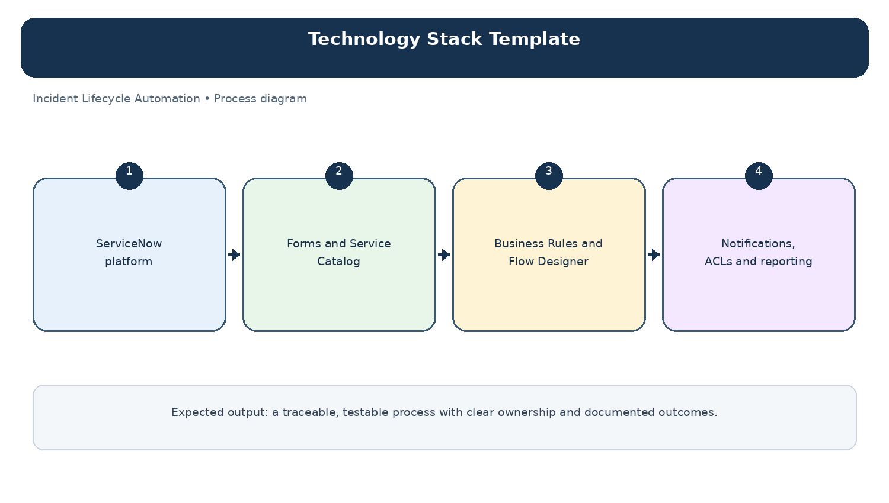
Diagram: Technology Stack Template — project-specific process overview.

